DONATION FROM NESTLE (MALAYSIA) SDN BHD
Recently, our Home has received a generous donation
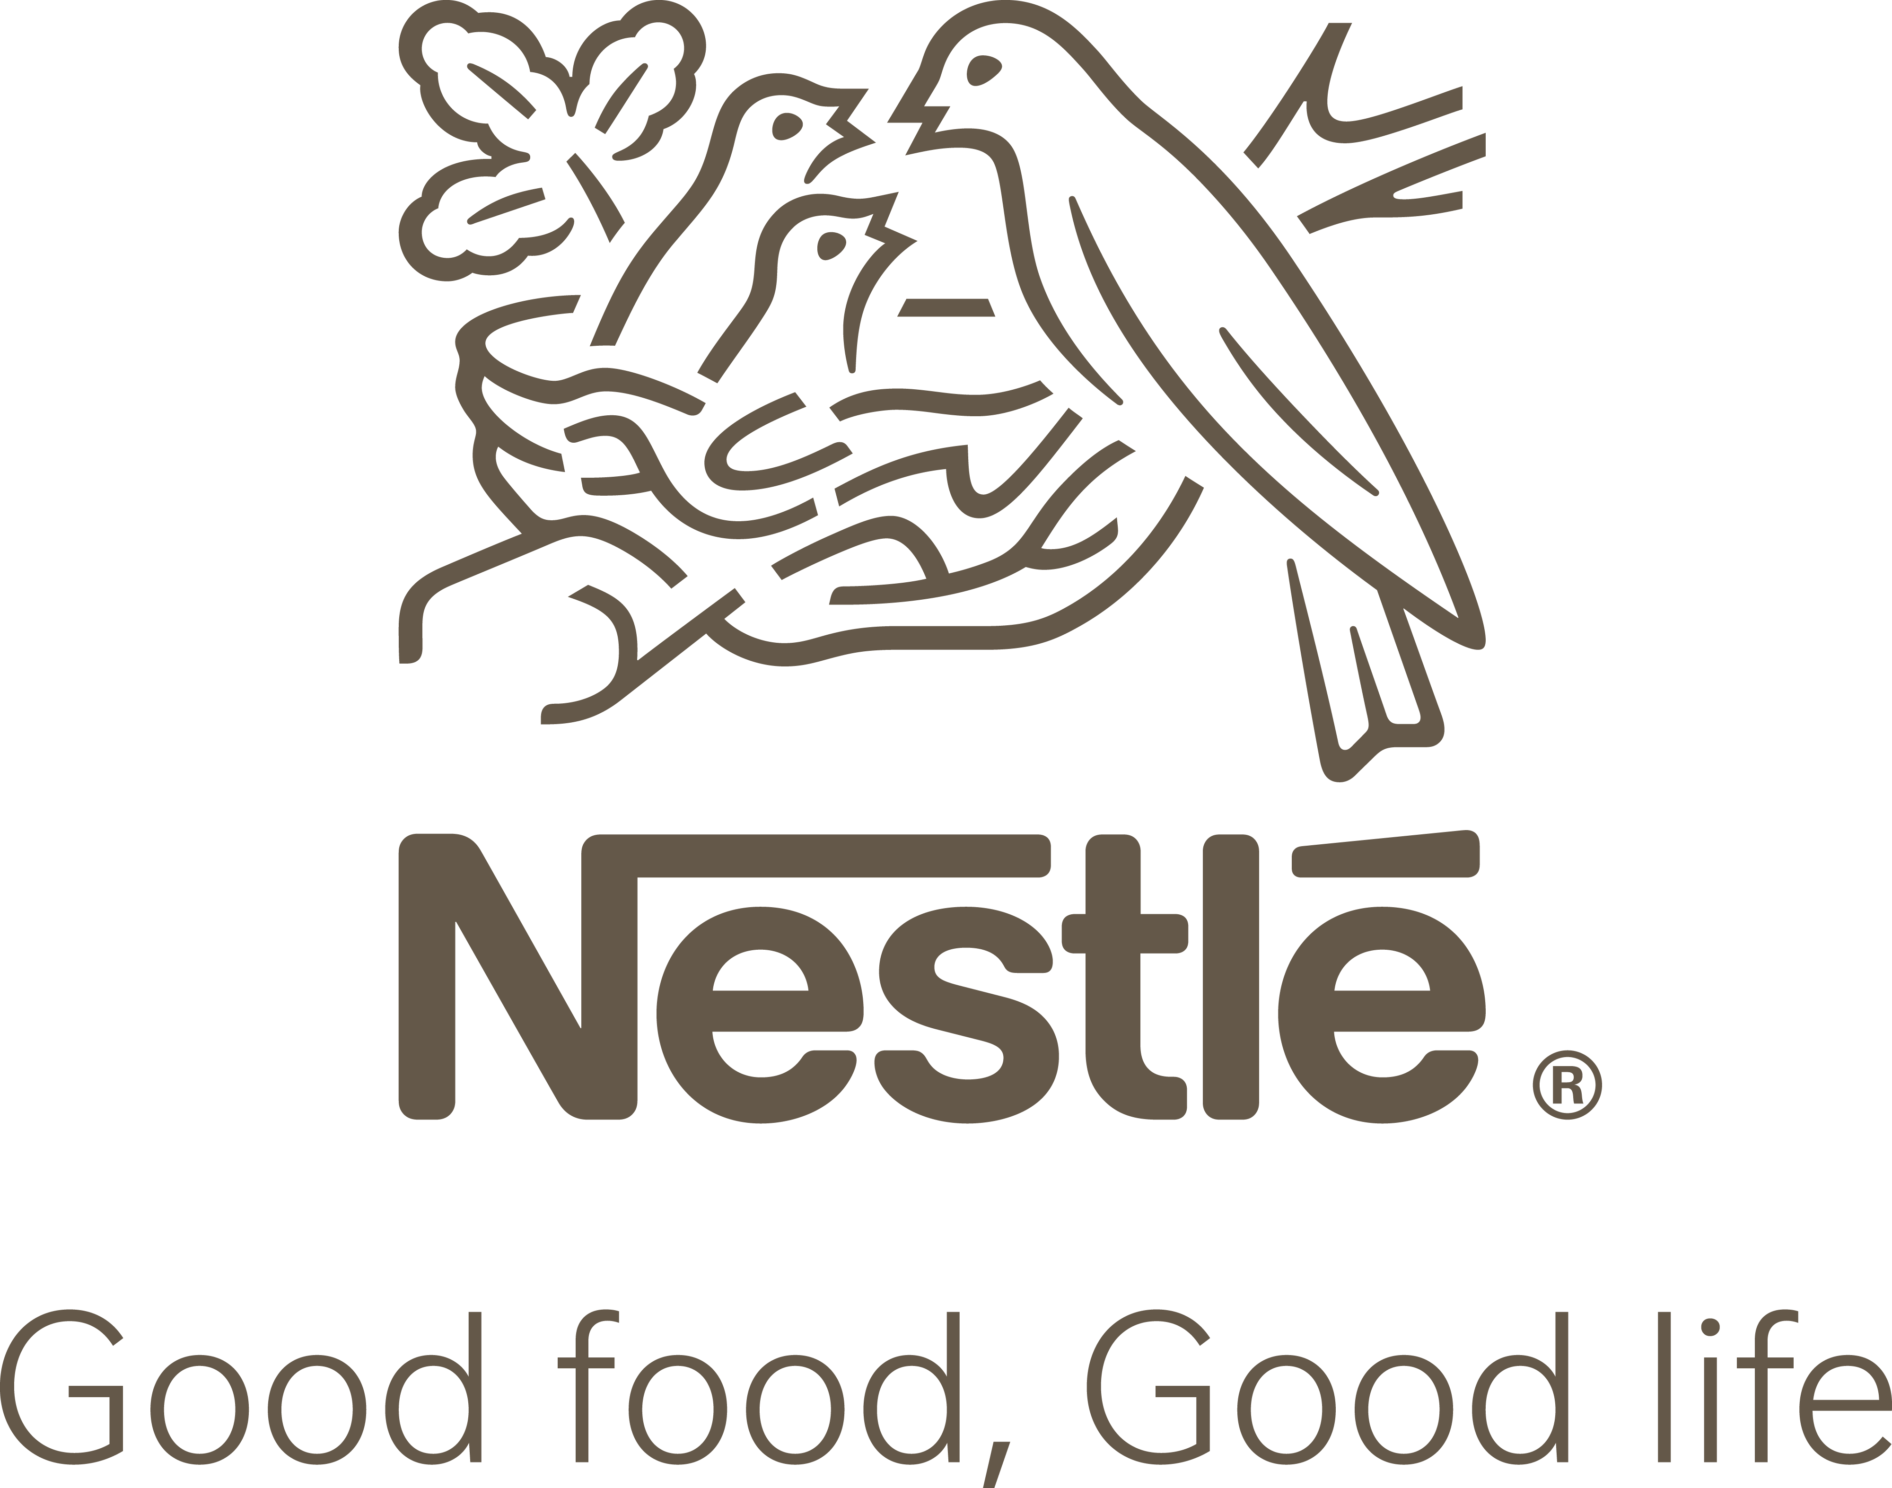
of food and stuff and beverages from Nestle (Malaysia) Berhad on 19th December 2023, 28th December 2023 & 22nd January 2024 namely, Nestle Omega Plus products, Milo Activ-Go, Maggie 2-Minn, Nescafe Classic, Nestum and Nespray Softpacks. A big “Thank You” to Nestle (Malaysia) Berhad as your donated items are well appreciated, meaningful and helpful in sustaining maintaining the healthcare of our Residents. We look forward to your continuous support!
